Greetings,
Our 8th Annual Manufacturers” Summit will take place at the Riverside Convention Center on Thursday, February 14, 2019. The theme this year will be “Finding, Training, Hiring and Retaining Makers” and we need to raise over $100,000 to support the event and the annual activities of the MCIE.

Your support will have a direct, positive impact on the jobs and economy of our region.

Student Manufacturing Summit – the future of manufacturing!
At the 2018 Summit, due in part to your support, the MCIE produced a parallel event for high school students. About 300 students attended and learned about the great careers awaiting them in manufacturing. This year, our Student Manufacturing Summit will take place on February 13th and will feature the nationally held Rube Goldberg Machine Competition. Middle school and high school students will also learn about careers from Tesla, see makers’ demonstrations, and receive training information from local colleges and technology trainers.

We can’t meet our goals without the help of organizations like yours.
That’s why I’m writing to you. Would you consider making a donation of $1000 for a vendor booth, or up to $10,000 in sponsorship for additional benefits. Your support will help us accomplish the goals of a strong, trained, manufacturing workforce and you will be joining Norco College, San Bernardino Valley Community College District, and Chaffey College in this effort.
If you would like more information, please give me a call, or visit, http://mfgcouncilie.com/become-a-sponsor/ for more details about vendors and upper level sponsorships More general information is located at www.mfgcouncilie.com.

We hope that we can count on your help to make this years’ event one of our best yet.
Please let me know if you have any questions.
Best regards,
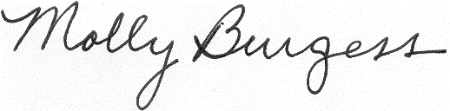
Executive Director
Manufacturers’ Council of the Inland Empire
909 474 7120

